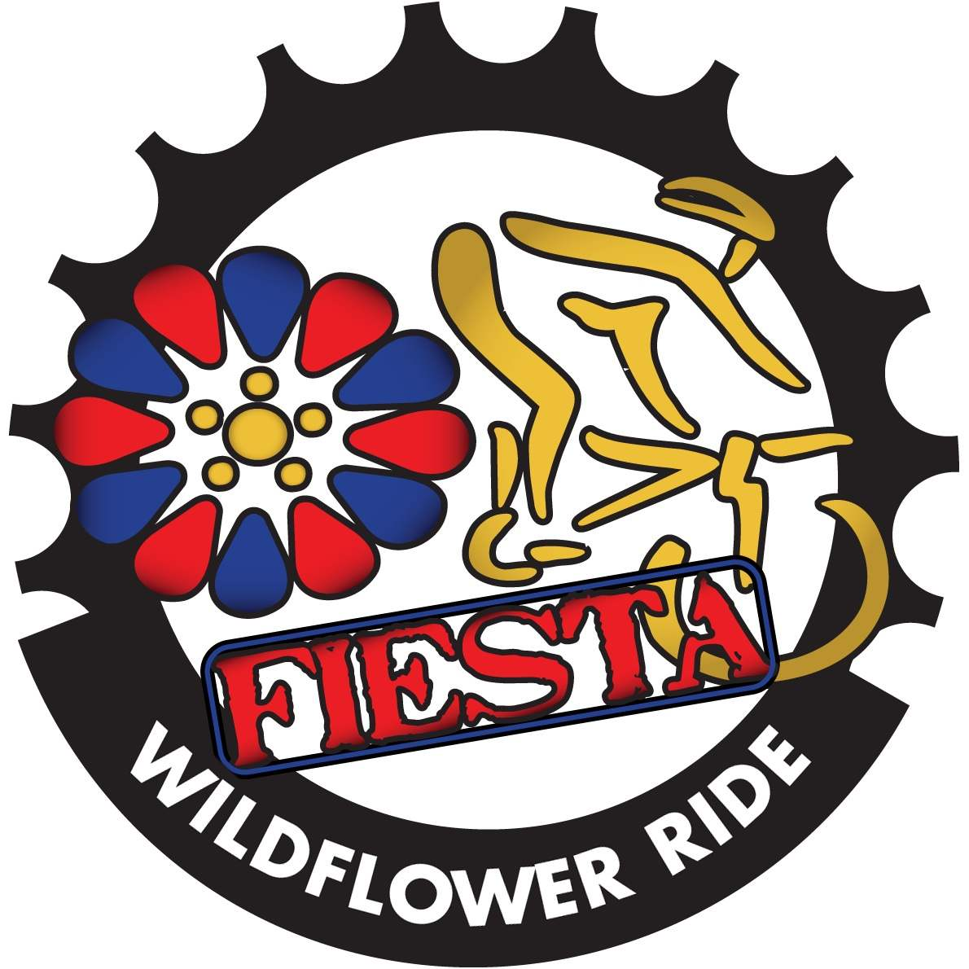

Welcome Riders!
Thank you for your support of the 2021 Fiesta Wildflower Ride. We appreciate you! Please read this document carefully. By following the guidelines included here you will have a safe and memorable experience. We’re so happy you are spending your Sunday with us! Enjoy the day!

Approximately 200 volunteers are helping to ensure you have a great day. Many have been working for months contributing their valuable time and resources to make this event a success. Several police departments will be assisting riders with safe passage along the routes. Please be courteous to the volunteers and the police along the course. We ask that you partner with us to make sure our police officers providing traffic control and all the volunteers want to return next year!
______________________________________________________________________________________________

Packet pick up-

Rolling Oaks Mall
6909 N Loop 1604E
San Antonio TX 78247
Thursday June 17th from 4pm-7pm
Friday June 18th from 4pm-7pm
Saturday June 19th from noon-7pm
The above packet pick up times will be located inside the mall. Park near the main entrance on the lower level of the mall. We will be in the main court area near JCPenney.

IMPORTANT
*If you are picking up multiple packets please have all names legibly printed or typed on a piece of paper for the volunteers to work from. You will be required to print and sign your name, provide your ID and we will keep the paper for our records*

EXPO will be held on Saturday June 19th from noon to 5pm.
Please show your support to our sponsors and the vendors that will be present. By coming to the expo you help it grow!

There will be an additional packet pick up opportunity on Sunday before the ride from 7-8. This will be located about halfway down the starting chute…look for the chaos and you’ll know you’ve arrived!
We encourage you to pick up your packet at any of the other times listed above if at all possible. If you must pick up your packet Sunday please arrive early and bring your patience since it’s sure to be crowded.

Helpful Hints:
* Arriving early to pick up your packet typically doesn’t work since the volunteers will be setting up the area.
* DO NOT pick up a packet for someone else unless you have made prior arrangements to do so.
* Thursday is not the best day to pick up your packet. Volunteers are much smoother by Friday and nearly professionals by Saturday!

***We are unable to exchange tee shirts at packet pick up. If you decide you need a different size check back with us when you RETURN from your ride on Sunday. If you registered too late to get a tee shirt in the size you wanted or at all please check back with us Sunday morning when you RETURN from your ride. We would be happy to accommodate you at that time if possible. We can’t do exchanges before the ride on Sunday because there will still be riders picking up their packet right up until the start. If you have a family member or friend that would like to exchange for you that’s fine they’ll just need to wait till the retail area is set up.***

Pre- Ride Prep:
It is important to prepare for your ride in advance.
*Fill out emergency data on the back of your ride number. (Number goes on the back of your jersey and the small sticker goes on the front of your helmet)
*Come to the event with two full water bottles
*You MUST wear a helmet. no exceptions. Any rider seen without a helmet will be asked to surrender their ride number and asked to leave the course. There are no refunds.
*Make sure your bike is in good condition and is mechanically sound
*Pump up your tires
*Pack extra tubes and supplies to take care of minor mechanicals out on the course
*Take energy gels and bars with you on the ride. The ride will have fully stocked rest stops but you don’t want to be 5 miles from nowhere without nutrition if needed.
*Wear sunscreen even if it’s cloudy!

Event Parking-
Anticipate the chaos! Please arrive early and allow time for traffic congestion. Please plan on arriving by 7am to give yourself time for last minute needs: porta potties, pumping up tires, helmet/shoes etc. All 4 entrances to the mall will be open, feel free to use them and avoid waiting in long lines to enter the parking lot. The event is staged on the back side of the mall near Incarnate Word/JCPenney. Please refer to the parking diagram on the event website. We are authorized to park in the front lots near Macy’s, Dillard’s and the main entrance. Helmets required while riding your bike.

http://www.fiestawildflower.com/mainimages/maps/wf-maps-parking.pdf

ROLLING OAKS MALL
6909 N Loop 1604E
San Antonio TX, 78247

Teams with space reserved:
We suggest arriving at 6:30 to set up your team canopy and supplies. Please unload supplies, move your car, and return to do the set up. You will find your spot labeled and you will have a bike rack available for your riders to use. Parking shouldn’t be a problem at that time-park by JCP(backside) which is the closest store to finish area. Make sure your canopy is secured and weighted down…we don’t want any blowing away while you are riding!

Start Line-
Opening remarks will begin at 7:30 and will include any necessary updates.
Line up according to the distance you plan to complete. You will see flags that designate your start area. Line up BEHIND the flag for your distance.

60mile FAST PACE (20mph average)- Blue Flagdeparts at 8am
60mile FUN PACE- Red Flagdeparts at 8:05
40mile- Green Flag departs at 8:10
20mile-Black Flag departs at 8:15

Route Detailsvery important please read completely!!!

Safety First:
*Follow ALL traffic laws. Unless you are directed by a uniformed police officer to pass through you are required to stop at all traffic lights and stop signs.
*NEVER EVER pass a rider on the right! If you are passing someone please call out “on your left” so they will know you are coming around. Don’t assume the rider in front can hear you behind them.
* When exiting the mall pay special attention and ride single file. There is construction happening along Nacogdoches.
* Please be mindful of your speed when going down Krueger Canyon(60&40mi. routes). This is a very fast descent. SLOW DOWN and stay to the right of the road. You are responsible for controlling the speed of your bike. Do not endanger others with excessive speed.
*If you see a stranded rider on the road and you can help, please do. We will have lots of newbies participating and seeing that kind of support from our more experienced riders will help grow our sport.
*Never ride more than two abreast. If you are on a narrow road or see any traffic at all please ride single file.
*If you are joining a group of riders out on the road make your presence known. Talk to the riders around you and don’t follow too closely… especially if you don’t have experience riding behind that person.
*When pulling into a rest stop make it known to the riders around you that you are stopping. Pull completely off the road at the rest stops

Stay on Track~

We have provided 3 ways to help you stay on track. We suggest every rider utilize at least two so that one provides you with a back up!

- Printed map. The printed map will show you an overview of your route and provide you with turn by turn directions as well as distances from one turn to the next.
- Signs out on the course showing you which way to turn. The directional signs are placed 3ft from the edge of the road and far enough from the approaching turn to allow for time to slow down. These signs will all have the event logo. Follow the arrows according to the distance you have chosen and the ones that say “all riders”.
- Downloadable GPX file for all you techies is also available on the event website. General info tab then Maps on the pulldown. Please read helpful hints to complete the process if you are unsure.
www.fiestawildflower.com

Please note: While we make every effort to mark the course with signage we can’t always get out to replace signage that has been stolen or knocked down. It is in your best interest to use your map while on the ride and review it before the ride.

Helpful Tips:
*Remember this is an open course. There may be other riders out for a Sunday spin. Don’t assume that if you see riders turning that you should follow them, especially if you don’t see a route sign and your map hasn’t directed you to.
*Remember there will be sections of your route with miles passing before you turn. This doesn’t mean you are lost. If you are worried look at your map to check. Remember… two forms of directions!

*These routes would be considered hilly by most standards. If you haven’t adequately trained please line up with a shorter distance. Nothing takes the fun out of a ride faster than it lasting too long!

Details by distance Please read all details for your route below:

Rest Stops Menus:
Water, SIS Labs Electrolyte Drink, Pickles, Bananas, Breakfast Bars, Gels, variety of cookies, and other misc. treats.

Rest stops are not self serve. Volunteers are on hand to help. Just let them know what you need.

60 Mile Metric Challenge:

Route Alerts:
Mile 16.8 going down Krueger Canyon. This is not your average downhill. It is extremely fast. EVERYONE SLOW DOWN. Remember not all on the course are experienced riders. Stay to the right and NEVER cross the midline. Course is open to traffic.
Mile 25-30 This is a course revision due to construction. Follow the signs!
Mile 30 NEW rest stop location: Hard Luck Auto.
Mile 47.6 Use caution when approaching Engel/IH35. It is not a 4 way stop! Cross traffic does not have a stop sign.

Rest Stops:
Mile 6.6 Schoenthal Rd North early rest stop if needed. Please pull completely off the road
Mile 18.3 Solms Park rest stop
Mile 30.4 Hard Luck Auto rest stopbetter stop at this one-about 13.4mi until the next stop
Mile 43.8 Santa Clara City Hall
Mile 52.4 at John Paul HS
Please take note of distances between stops and plan accordingly.

40 Mile Route:
Route alerts:
Mile 16.8 Very steep downhill Krueger Canyon. This is not your average downhill. It is extremely fast. EVERYONE SLOW DOWN. Remember not all on the course are experienced riders. Stay to the right and NEVER cross the midline. Course is open to traffic.
Mile 27.3 Use caution when approaching Engel/IH35 cross traffic does not stop and then pay attention. Very short distance on access road (.2) before the right onto Marigold.

Rest Stops:
Mile 7 Schoenthal Road North this is a new stop so pay attention
Mile 18.2 Solms Park Rest Stop
Mile 31.7 at John Paul HS
Please take note of distances between stops and plan accordingly.

20 Mile Route
Just a few turns on this morning ride! You’ll have a chance to stretch your legs at the rest stop located at John Paul HS. Rest stop is at mile 9.3

Road Crew:
First Aid: first aid kits will be located at each rest stop for minor issues. A medic tent will be set up at the finish line should you need assistance at the conclusion of your ride.
Mechanical Issues: you must be prepared to service your own bike while out on the course. If you need assistance beyond what you are able to do there will be SAG support along the course to transport you to the nearest rest stop. Rest stops will have mechanical assistance provided by local bike shops. Please be prepared to pay for tubes etc. that you may require to get back on the road.
SAG Support: If you should need assistance because you are too fatigued to complete your chosen course you will be picked up and transported to a central rest stop where you will be directed to rest while waiting for transportation back to Rolling Oaks Mall. Please be patient while waiting. We will do our best to make it happen in a timely manner. If you even think you might be stretching yourself with the distance you’ve chosen please consider going with a shorter distance. It will surely be a HOT June day!

Finish Line-
***PLEASE SLOW DOWN WHILE APPROACHING THE FINISH LINE***
Please stay and enjoy the post event festivities. Kiolbassa will be on hand at the BBQ pit making sausage wraps for all riders. There will be a tag at the bottom of your ride number which will be collected for food so have your number handy. Family and friends may purchase a meal for $5(cash only).
Event Tees, Water Bottles, Jerseys and Medals will be for sale as supplies hold out at the retail table.

***Additional meals for family/friends can be purchased for $5 where meal tickets will be collected (cash only)***

Our 2021 Partners make it happen! Please show your support as a thank you for their generous support local community events!
- Kiolbassa Provisions
- REDBULL
- SIS Science in Sport
- Felix Gonzalez Law
- San Antonio Trial Lawyers Association
- Broadway Bank
- Renewal by Anderson Windows
- EXO nutrition
- Action Bikes
- Britton Bikes
- Ride Away Bikes
- Crossroads Bike Shop
- Charles A James Bike Shop
- “On The Go” mobile bike service
- Rolling Oaks Mall
Thank you for supporting the 15th Anniversary of the Fiesta Wildflower Ride! We are so proud to partner with Morgan’s Wonderland and be part of San Antonio’s famous Fiesta!
Please use the hash tag #fiestawildflowerride on all your social media!

